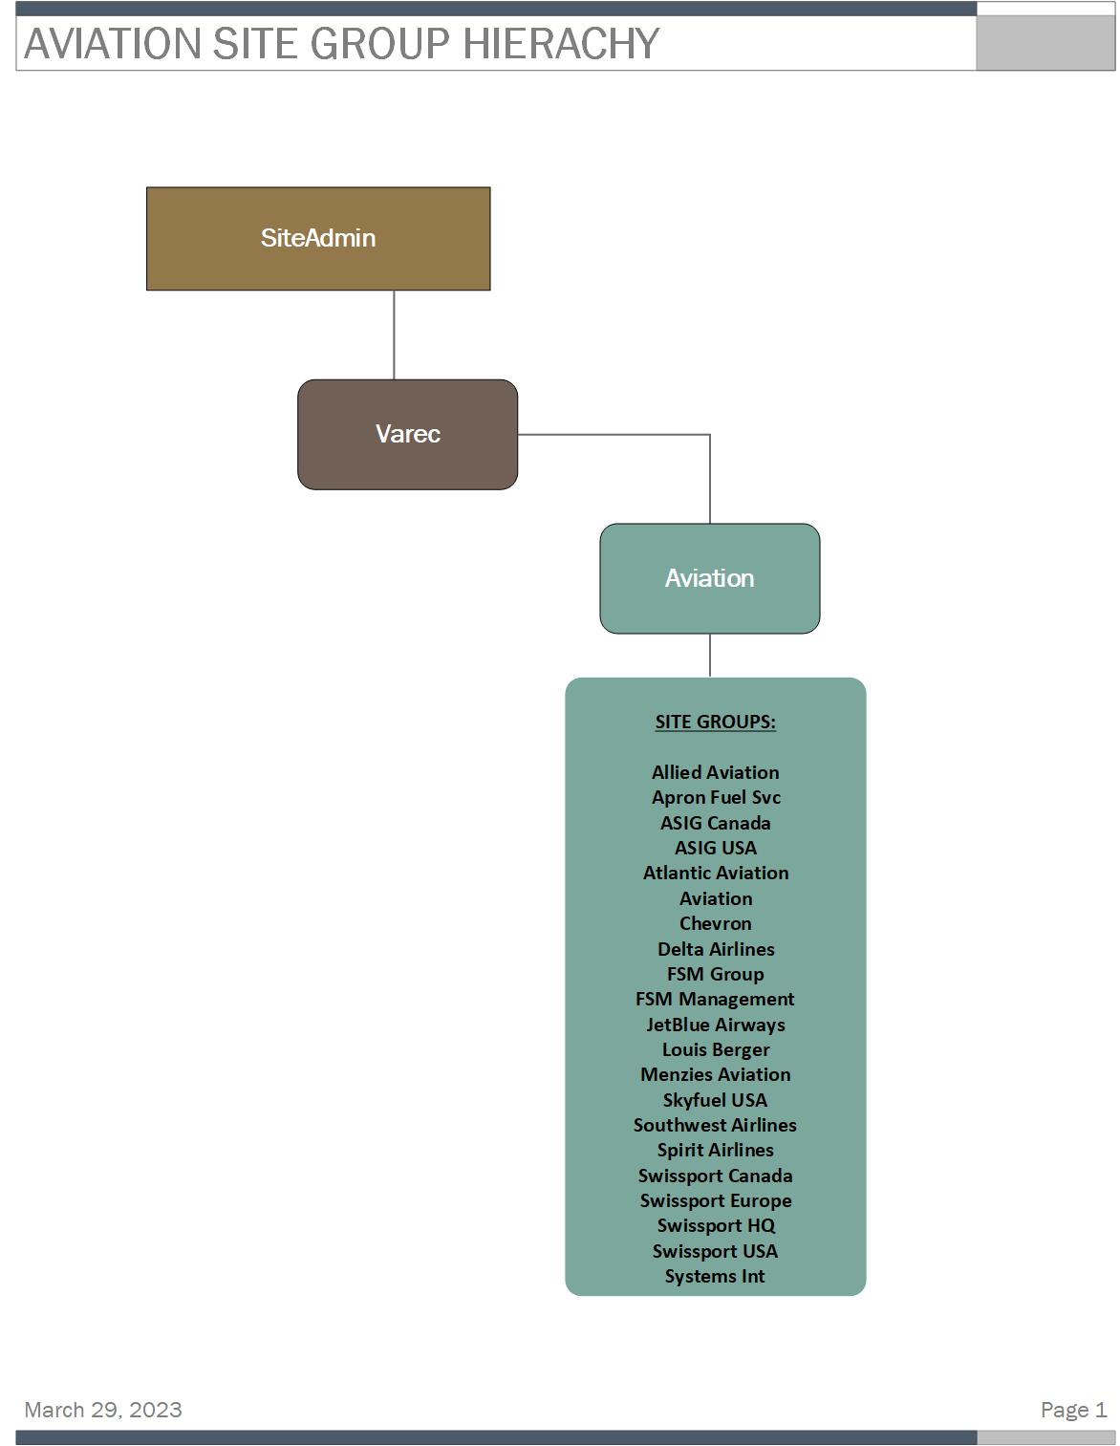

TABLES WITH AVIATION SITEGUID ASSIGNED DATA

ENTITY TABLES CONTAINING AVIATION SITEGUID DATA:
TABLE | COLUMNS | CONTAINS AVIATION  SITEGUID DATA
erv.tblEntityRecordVersioningFieldConfig | SiteGroupGuid | yes
map.tblCompanyCompanyToUserGroup | Siteguid | yes
map.tblCompanyToRole | Siteguid | yes
map.tblEntityCompanyToSite | SiteGuid, AssignedFromSiteGuid | yes
map.tblEntityEquipmentTypeToSite | SiteGuid, AssignedFromSiteGuid | yes
map.tblEntityLedgerViewToSite | SiteGuid, AssignedFromSiteGuid | yes
map.tblEntityListViewToSite | SiteGuid, AssignedFromSiteGuid | yes
map.tblEntityProductToSite | SiteGuid, AssignedFromSiteGuid | yes
map.tblEntityQuerySettingToSite | SiteGuid, AssignedFromSiteGuid | yes
map.tblEntityReportConfigurationSettingsToSite | SiteGuid, AssignedFromSiteGuid | yes
map.tblEntityTransactionAliasToSite | SiteGuid, AssignedFromSiteGuid | yes
map.tblEntityUserDataToSite | AssignedFromSiteGuid | yes
map.tblEntityUserGroupToSite | SiteGuid, AssignedFromSiteGuid | yes
map.tblEntityUserToSite | SiteGuid, AssignedFromSiteGuid | yes
map.tblSiteToSite | ParentSiteGuid, ChildSiteGuid | yes
map.tblUserToGroup | Siteguid | yes

DBO SCHEMA TABLES CONTAINING AVIATION SITEGUID DATA:
TABLE | COLUMNS | CONTAINS AVIATION  SITEGUID DATA
dbo.tblCompanies | Siteguid | yes
dbo.tblEquipmentTypes | Siteguid | yes
dbo.tblGeneralConfiguration | Siteguid | yes
dbo.tblGroups | Siteguid | yes
dbo.tblListViews | Siteguid | yes
dbo.tblProcessVariableSite | Siteguid | yes
dbo.tblProducts | Siteguid | yes
dbo.tblReportDetails | Siteguid | yes
dbo.tblReportGroups | Siteguid | yes
dbo.tblScheduleTerminalOperation | Siteguid | yes
dbo.tblSites | Id, SiteGuid | yes
dbo.tblSitesAncillaryData | SiteGuid | yes
dbo.tblSitesShadow | Id, SiteGuid | yes
dbo.tblTransactionAliases | Siteguid | yes
dbo.tblUserDataFieldTransactionAlias | Siteguid | yes
dbo.tblUserDataFieldTransactionAliasLineItem | Siteguid | yes
dbo.tblUsers | Siteguid | yes

INITIAL ANALYSIS OF TRANSACTIONAL AND ENTITY DATA:
- Transactions:
  - No transactions are assigned directly to Aviation siteguid.
- Sites:
  - No sites are directly assigned to Aviation, only at site groups level.
- Companies:
  - There are companies mapped directly to the Varec >> Aviation hierarchy and others only mapped to Aviation.
- Products:
  - There are products assigned directly to Aviation and others from Aviation to Child sites.
- Equipment:
  - No equipment assigned directly to Aviation.
- EquipmentTypeToSite:
  - There are EntityEquipmentTypeToSite assignments to Aviation.

STEPS TO REMAP AVIATION AND RELATED SITEGROUPS TO VAREC

- Hierarchy change:
  - Create a new hierarchy Site-to-Site mappings from Varec to all the Site and Site groups under Aviation.

- Change entity ownership from Aviation to Varec

- Copy all Entity-to-Site mappings assigned from Aviation, to Varec (with Varec being now the AssignedFromSiteGuid)
- Modify Aviation siteguid data in the identified dbo schema tables and assign them the Varec siteguid. (See: TABLES WITH AVIATION SITEGUID ASSIGNED DATA - page 2)

- Validation of Changes:
  - Development validation – Data integrity: All data that was re-mapped from Aviation siteguid is now mapped to Varec. There are no orphaned records, no table constraint errors.
  - QA Validation – Application functionality & reports where applicable for all related entities and transactional data that was previously re-mapped from Aviation to Varec.

- Data Cleanup:
  - Delete all site-to-site mappings to and from Aviation.
  - Delete Aviation Site

- Validation Changes: Repeat Step 5.

